Lesson 7 – Conditional Statements

Boolean Variables
Relational Operators
Logical Operators
If Statement
If-Else Statement
If-Else-Else If Statement
MAX Algorithms
What students should know
4h

Logical Variables
So far, we have seen three types of variables integer, real, and string. As a type it is extremely simple because it can accept only two different values: True – False which in fact internally on the computer are translated into states 1 and 0 (leaked by current or not).
The statement of a logic (from now on we will call it Boolean) becomes like the other simple variables we have known:
Private intDistance = 100, intTotalTravel = 0 As Int
Private blnFlag As Boolean = False
Private blnDone As Boolean

Comparative Operators
Comparative operators are used to make comparisons between values in the programming languages. They are the known mathematical symbols of inequalities only that on the computer are written in a slightly different way.
Mathematical Symbol | B4X | Meaning
= | = | Equality
≤ | <= | Smaller or Equal
≥ | >= | Greater or Equal
≠ | <> | Different
< | < | Smaller
> | > | Larger

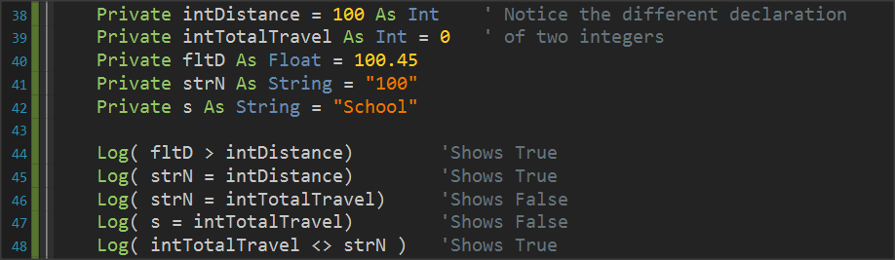
Generally, to make a comparison you must compare variables or values of the same type. Eg. Integer values with integer values, real with real prices, etc. Also, in B4X you can compare numeric variables, such as integer variable and float, or Strings (strings) and numeric variables because internally the language converts strings into numbers.
Remember
The result of a comparison is always a logical value of True or False.
Picture 1 Variable Comparisons

Logical Operators
Consider a sentence such as 'I am going to school now'.
Mathematician George Boole developed an algebra based on logical sentences.
In Mathematics and Mathematical Logic, Boolean Algebra is the algebra where the values of the variables are the true and false, usually represented by 1 and 0 respectively. Unlike elementary algebra where the values of variables are numbers and the main acts are addition and multiplication, in Boolean there are three main acts And, OR and Denial No.
Remember
AND (conjunction), denoted x AND y, satisfies x AND y = 1 if x = y = 1, and xANDy = 0 otherwise.
OR (disjunction), denoted x OR y, satisfies x OR y = 0 if x = y = 0, and x OR y = 1 otherwise.
NOT (negation), denoted NOT x, satisfies Not x = 0 if x = 1 and Not x = 1 if x = 0.

Example:
1st Sentence: Today it rains, 2nd Sentence: I am going to school.
Today it's raining.  (P1) | I am going to school.  (P2) | P1 AND P2 | P1 or P2 | NO P1
True | True | True | True | False
True | False | False | True | False
False | True | False | True | True
False | False | False | False | True

From the table we observe that
- Two sentences that unite with the logical AND are true when it unites two truths only.
- Two sentences that are united by logical OR are true when even one sentence is true.
- The logical NO reverses the truth or lie of a sentence.

Logical operators in programming
Logical operators are used in programming to create complex comparative expressions. This helps the developer optimize their code with fewer lines and simpler code.
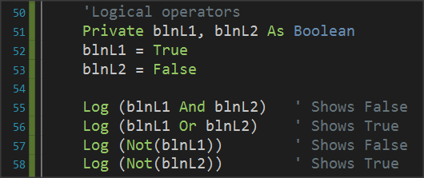
In B4X logical variables are used as below.
Picture 2 Use of Logical Acts
Notice that logical operations must link logical variables or logical expressions as we will see later.

Examples of evaluation of logical sentences.
The following variables are given with their values:
Private intA = 10, intB = 20, = 30 As int
Private strName1 = “George”, strName2 = “Georgia” As String
Private blnA = True, blnB = False blnC = False As Boolean

Calculate the value of the following logical expressions.
1.
blnA | AND | blnB
True |  | False
 | False

2.
Inta | > | intC | AND | blnA
10 |  | 30 |  | True
 | False
 |  |  | False

3.
intA + intB | >= | intC | AND | (blnA | OR | blnB)
10 + 20 |  | 30 |  | True |  | False
 | True |  |  |  | True
 |  |  | True

4.
intA + intB | >= | intC | OR | (blnA | AND | blnB)
10 + 20 |  | 30 |  | True |  | False
 | True |  |  |  | False
 |  |  | True

5.
strName1 | = | “George” | OR | strName2 | = | “John”
George |  | George |  | Georgia |  | John
 | True |  |  |  | False
 |  |  | True

If command
Often as in life we ask questions so in programming there is a need for the developer to ask questions to check values or change the continuity of the program in different directions.
The if command is used to make the corresponding questions:
Its basic form is as follows:
If ( condition ) Then
Commands
End If
Where condition enter a comparative or logical expression studied above.
The meaning is: If condition is TRUE execute the commands between Then and End If
Examples:
Private intA = 10, intB = 20 As Int
Private fltA As Float

If intA > 0 Then
Log(intA & " is positive Number")
End If

If intA > 10 Or intB > 10 Then
Log("One or both numbers are greater than 10")
End If

If intA Mod 2 = 0 Then
Log(intA & " is Even number")
End If

If – Else
The Else command adds the ability to if to execute code if its condition is not true.
Its basic form is as follows:
If ( condition ) Then
Commands
Else
Commands
End If

The meaning is: If condition is TRUE execute the commands between Then and Else otherwise Execute the commands between Else and End If.

Examples:
Private intA = 10, intB = 20 As Int
Private fltA As Float

If intA > 0 Then
Log(intA & " is possitive Number")
Else
Log(intA & " is not possitive Number")
End If

If intA > 10 Or intB > 10 Then
Log("One or both numbers are greater than 10")
Else
Log("None of the two numbers are greater than 10")
End If

If intA Mod 2 = 0 Then
Log(intA & " is Even number")
Else
Log(intA & " is Odd number")
End If

If – else - else if
Multiple if further extends the functionality of an if command by adding more than 1 control to the structure.
How to write:
If ( condition1 ) Then
Commands
Else If (condition2 ) Then
Commands
Else If ( condition3 ) Then
Commands
Else If ( condition4 ) Then
Commands
...
Else
Commands
End If

The function of the multiple if is summarized as follows:
- The first condition runs, and if it is true, then the code it contains runs and if it is completed.
- If the first if is false then the second is executed and if it is true it executes the code it contains and if it is completed.
- Other checks are always performed when the previous ones are false.
- If none of the checks are true then the else command is run which is optional.

Example 3
A fast-food chain has these meals:
Meal | Price
Burger | 5$
Pizza | 3$
Hot Dog | 1,5$

Create a program that:
Reads the meal the customer wants. Prints the cost of the meal. Input example: "Hot Dog", Output: "Hot Dog 1,50$"
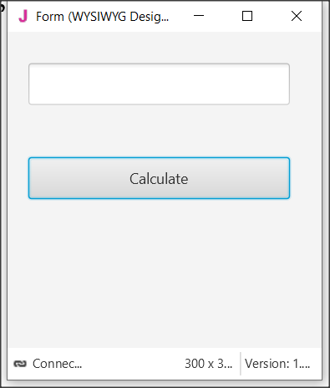
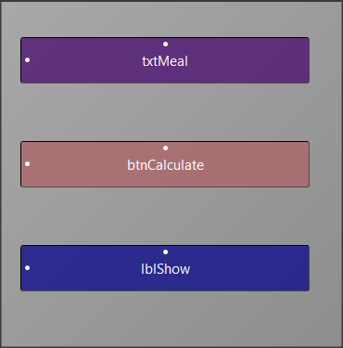
Solution
Picture The app screen
Step 1
Start a new project and give dimensions 300 x 300.
Step 2
In the designer design the app screen

Step 3
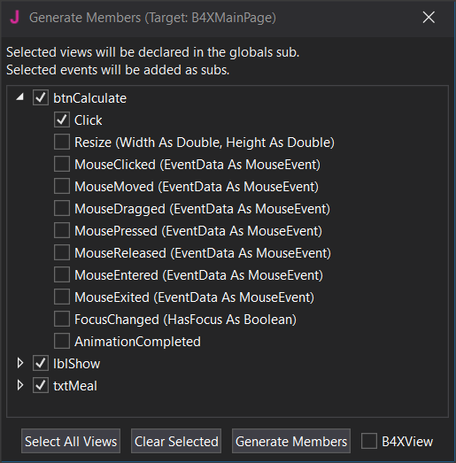
Enter txtMetal , btnCalculate, lblShow , and btnCalculate_Click.

Step 4
The code you need to write is for btnCalculate_Click
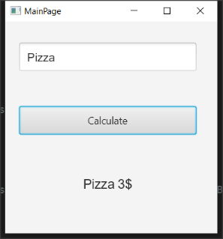
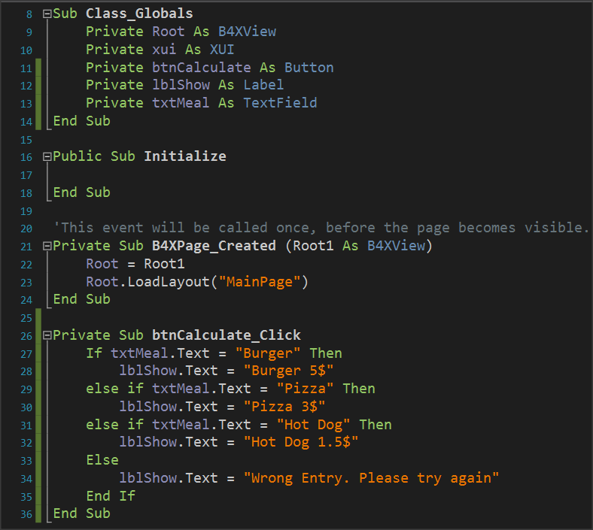
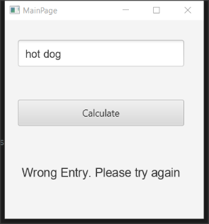

Note that the code considers capitals to be different from small letters. So he doesn't recognize the hot dog as a meal that should be written as a Hot Dog.

Algorithms with if
Find Maximum Number
Read 3 integers and find the largest in three different ways
Method 2 – Nested If
If Inta > intB then
If Inta > intC then
Log(Inta)
End If
End If
If IntB > IntA then
If IntB > intC then
Log(IntB)
End If
End
If IntC > IntA then
If IntC > IntA then
Log(IntC)
End If
End If

Method 1 – Simple If Statement
If Inta > intB AND Inta > intC then
Log(Inta)
End If
If intB > Inta AND intB > intC then
Log(intB)
End If
If intC > Inta AND IntC > intB then
Log(intC)
End If

Method 3 – Max Algorithm
Max = inta
If intB > Max then
MAX = intB
End If
If intC > Max then
MAX = intC
End If
Log(Max)

Exercises
- Make the following suggestions in logical expressions.
  - A belongs to space [-5, 6).
  - a is less than 3 or more than 15.
  - a is equal to b and c.
  - a does not have a value of 3.
  - A is less than 2 or b is greater than 78.
  - a and b true and c false.
  - the a true and one of the b, c true.

- What is the logical result (true or false) of performing the following operations if the following variables have the values below?
A = 10, B = 2, C = -4, D = 9 and E = 1
  - (A>B) or (D=10)
  - (D >= B) and (E <> C)
  - no (E<=C) or (D<=C)
  - no ((B<=C) and (D<2))
  - no (no (B<=E) or not (C<=B))
  - ((E<=A) and (E>=C)) and not (C>=A)
  - no (no (A >= 2) and (C <>9))
- A fast-food chain has these meals:
Meal | Price
Burger | 5$
Pizza | 3$
Hot Dog | 1,5$
Create a program that:
Reads the meal the customer wants and second how many items of this meal needs.
Prints the cost of the meal.
Input example: "Hot Dog", 2
Output: " 2 x Hot Dog 3$"
- You have consumed X amount of Mbps on Wikipedia and Y amount of Mbps on memes. The cost of visiting Wikipedia is 0,10$ per Mb and the cost for watching memes is 0,05$ per Mb. If total consumption is more than 100$ print "Too much consumption". If watching meme consumption is greater than reading Wikipedia consumption print "WOW MANY MEMES", "SUCH LOL"(in new line). Create a program that:
  - Reads X (Wikipedia Mb consumption) and Y(watching meme Mb consumption)
  - Calculates the total consumption.
  - If total consumption greater than 100$ print proper message If watching meme consumption is greater than reading Wikipedia articles print proper messages
- An internet cafe has 2 ways of charging. If the user is a member pays 2$/hour, Else the user pays 5$. Find if someone is a member or not and calculate the price based on how many hours the user spend. If the user is a member the tax is 10% else the tax is 20%. Create a program that:
  - Reads how many hours the user spend
  - Check if is a member.
  - Add the proper tax fee.
  - Print the total amount the user must pay Output: "The user is a member stayed 2 hours for 2$/hour plus the 10% the total amount is 4.4$"
- You want to buy something from Amazon. The seller charges different prices for shipping cost based on location. For US it's 5$ for Europe it's 7$ for Canada it's 3$ for other places it's 9$. Create a program that:
  - Reads the cost of the product.
  - Reads your location.
  - Print the amount of money you must pay.
  - Output: "You have to pay 23$, 20$ for the product and 3$ for shipping cost".

- A company sells a product for 0.70 € a piece if up to 200 pieces are ordered and for 0.50 € a piece if more than 200 pieces are ordered. Read the number of pieces ordered and calculate their value.
- A cell phone company has the following billing policy.
 | Fixed cost 25$
Call duration(in seconds) | Charge($/per second)
1-500 | 0,01
501-800 | 0,008
801+ | 0,005
Create a program that:
  - Reads how many seconds was the calls duration.
  - Calculates the monthly bill for the subscriber.
  - Prints the total amount.
  - Output: "total amount: 48$"
  - Notice that that the charge for the first 500 seconds it's 0,01$ then for the next 501 to 800 seconds it's 0,008 and then it's 0,005$

- In the qualifying races in the long jump at the Olympic Games, an athlete makes 3 initial attempts and if he has a performance of more than 7.50 meters, then he is entitled to continue and make another 3 more attempts. Read the first 3 attempts of an athlete and print a message whether he is entitled to continue or not and if he is entitled to find and print the best effort of the athlete.
You can use method Visible = True or False to hide or show labels, textFields and Buttons.
- In a municipality there are parking spaces for a short period of time. Parking charges are staggered, as shown in the table below:
Parking time | Charge per hour
Up to 1 hour 3.50 €
The next 2 hours | 8.00 €
The next 2 hours | 12.00€
Over 5 hours | 15.00 €
Make a program that reads the duration someone left his car in parking and calculates the total cost.

